Dear Employee:

Click here to enter text is committed to helping the City divert waste from the landfill and staying compliant with the Recycling and Composting Ordinance. Through this ordinance, everyone in Palo Alto is required to place their discards into the appropriate container – compost, recycle, or landfill.

It is our goal to make it easy for you to compost and recycle. Please contribute to making our composting and recycling program a success by properly separating your compostable and recyclable materials from your garbage.

What this means for you:

Composting
Separate your food scraps and soiled paper and place them in the green composting containers located Click here to enter text.
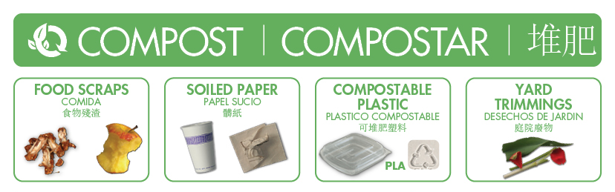

Recycling
Separate your recyclables, including hard plastics, bagged film plastics, paper, cardboard, glass, metals, and electronics, and place them in your blue recycling containers located Click here to enter text. The cans under your desk should be for recyclables only or removed all together. Bottles and containers need to be empty of food and liquid. Paper needs to be clean and dry.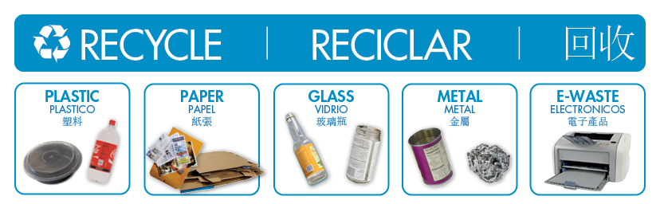

Garbage/Landfill
Very little material is actually landfill. Separate your Styrofoam™, snack packaging, and aseptic containers and place them in your black landfill container located Click here to enter text.
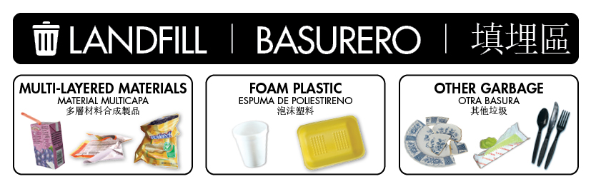

Resources:
- For a full list of recyclable and compostable items, click Here.
- To test your understanding, play this quick sorting game.
- Follow @GreenWastePA on Instagram, Facebook, or Twitter for sorting guidance, zero waste tips, and a peek inside our processing facilities.

Questions?
If you have any questions, please contact Click here to enter text at Click here to enter text.

Thanks again for your interest and cooperation.
Sincerely,
Click here to enter text.

